- Occurrence of Major Symptoms in PASC Cases:
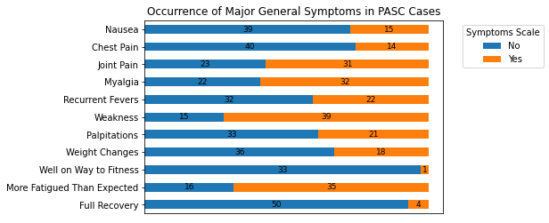

- Occurrence of Major Symptoms in PASC Cases (%):

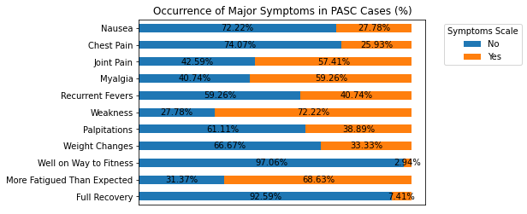

- Occurrence of Major Mental Health Symptoms in PASC Cases:
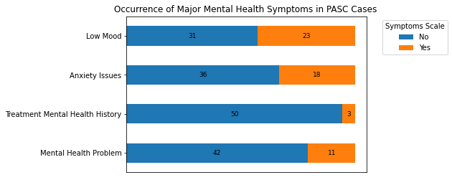

- Occurrence of Major Mental Health Symptoms in PASC Cases (%):
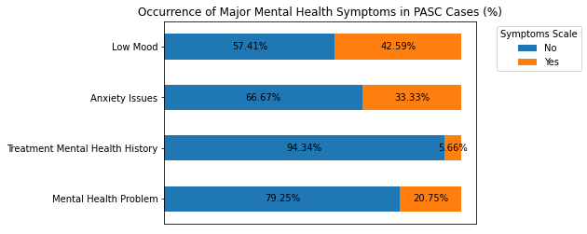

- Occurrence of Major Neurological Symptoms in PASC Cases:

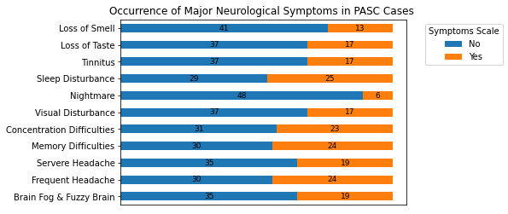

- Occurrence of Major Neurological Symptoms in PASC Cases (%):

